**AR APPLICATION PROGRAMMING PROTOCOL FOR ANDROID**

***Version 1.0***

**Produced by: Ivan Alexander Rulik Cote**

# OBJECTIVE

The protocol aims to present a fast method for developing augmented reality applications on personal computers.

# SCOPE

Provide tools that can range from entertainment to visual aids for processes inside and outside the clean room laboratory.

# STEP BY STEP

## PREPARATION: SOFTWARE

For the following steps, it will be necessary to download the following software and SDK:

* Unity Personal (free): it is necessary to create an account on Unity.
* <https://store.unity.com/es/download/thank-you?thank-you=personal&os=win&nid=222>
* Registration in Vuforia (to download the SDK it is necessary):
* <https://developer.vuforia.com/user/register>
* Vuforia SDK for Unity:
* <https://developer.vuforia.com/downloads/sdk#downloadModal>

## PREPARATION: LICENSE

1. We log in to the Vuforia ™ development portal (https://developer.vuforia.com/home-page#), and go to the Develop tab and in the License Manager subcategory, click Add License Key.

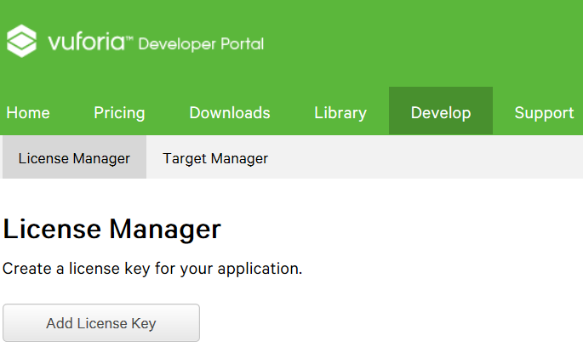

Figure 1: Vuforia ™ License Manager.

1. We specify that our project is for development, we give a name to our future application and continue.

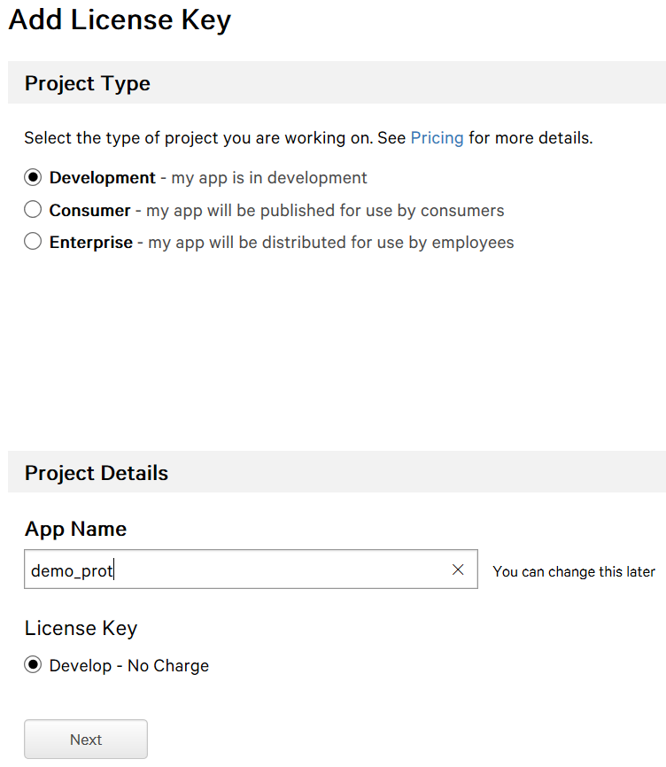

Figure 2: Generating a license for the app.

1. We accept and confirm.

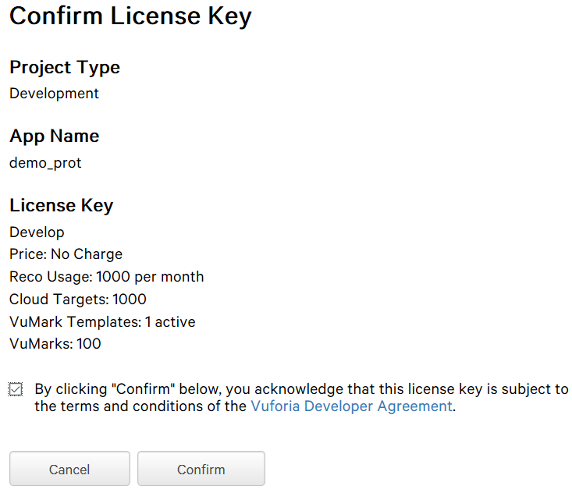

Figure 3: License confirmation window.

1. We can see that our app already appears in our License Manager.

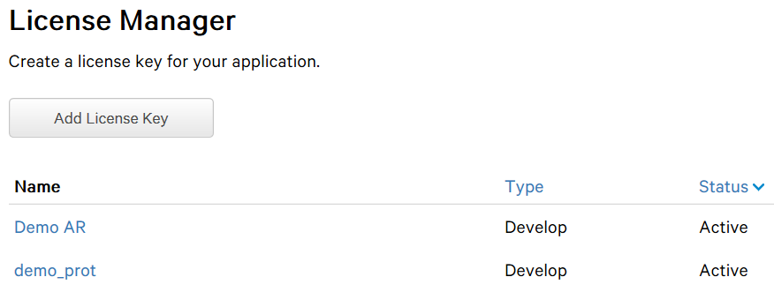

Figure 4: Updated License Manager.

1. We click on our app and we will get the license key which we will copy to use in a moment.

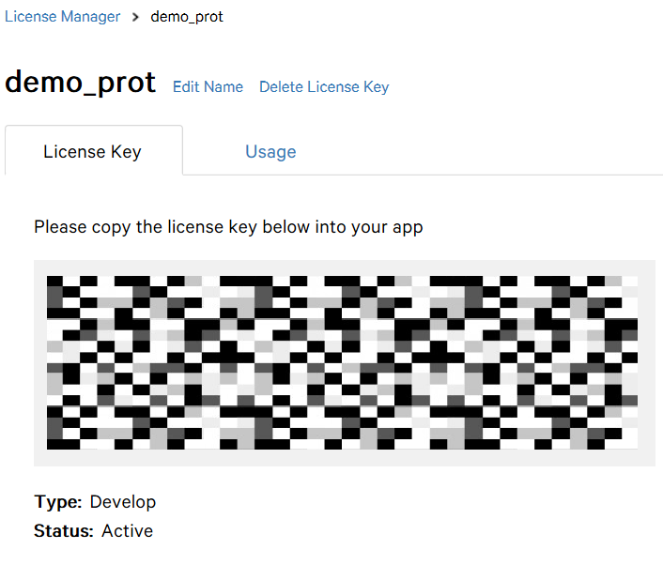

Figure 5: Key, generated license.

## PREPARATION: TARGET

1. First, we will download this sample image:

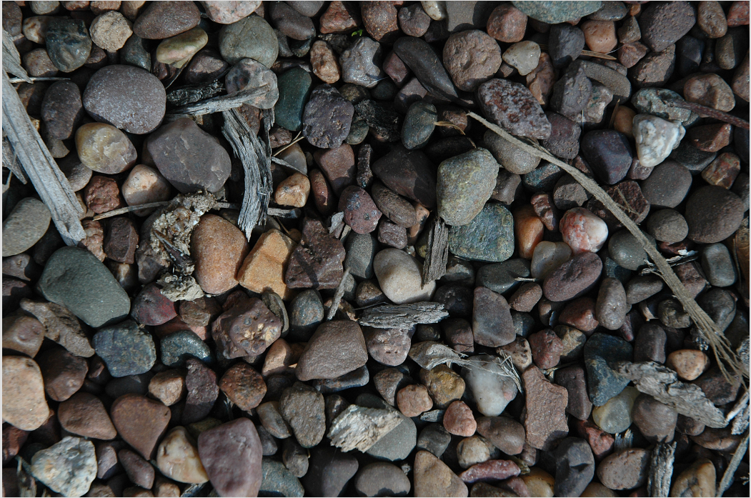

Figure 6: Augmented Reality Target (http://www.textureking.com/dsc_5692/).

1. Now we will enter the Target Manager subcategory in the Develop tab of Vuforia™ and click on Add Database.

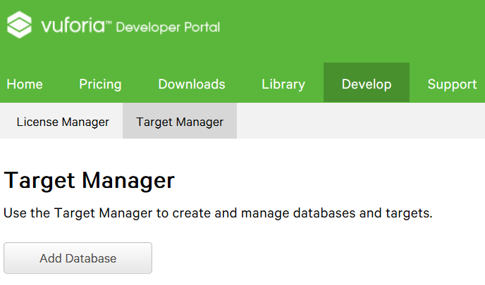

Figure 7: Vuforia™ Target Manager.

1. We assign a name to our target library, select Device, and click Create.

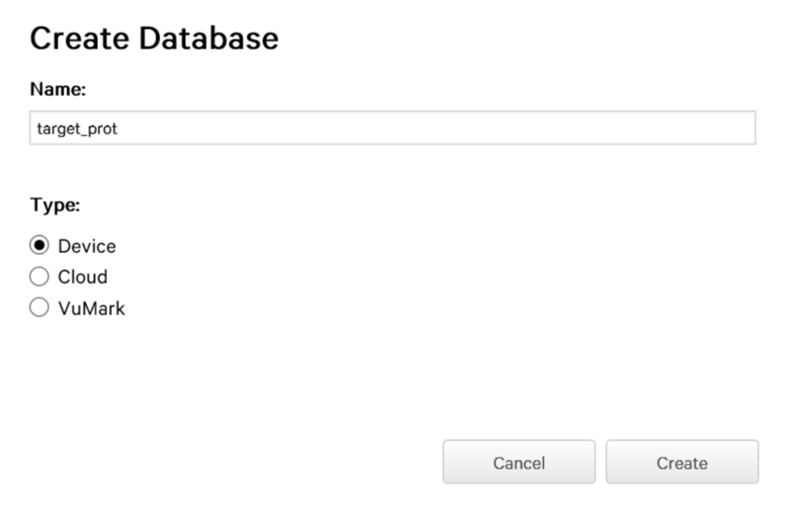

Figure 8: Window to create a database (targets).

1. We click on our new library to continue.

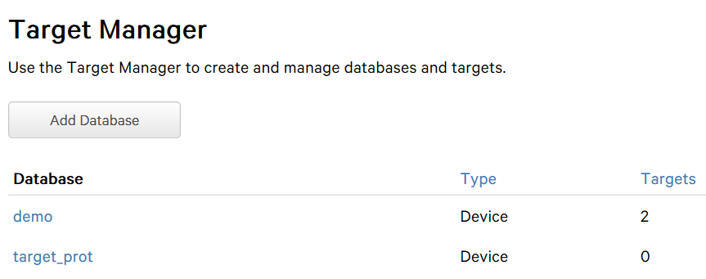

Figure 9: Updated Target Manager.

1. Then we click on the Add Target option.

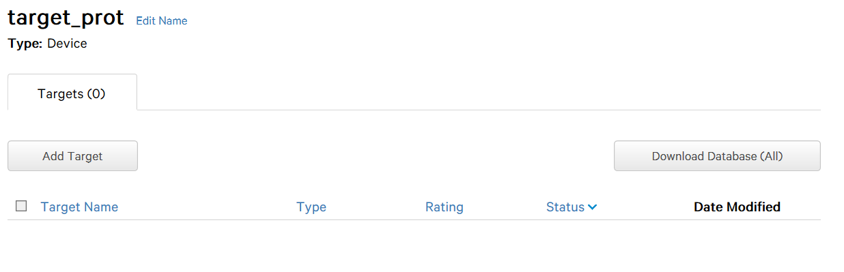

Figure 10: Generated library.

1. We look for our downloaded image at the beginning of the preparation, put a length of 1, and click Add.

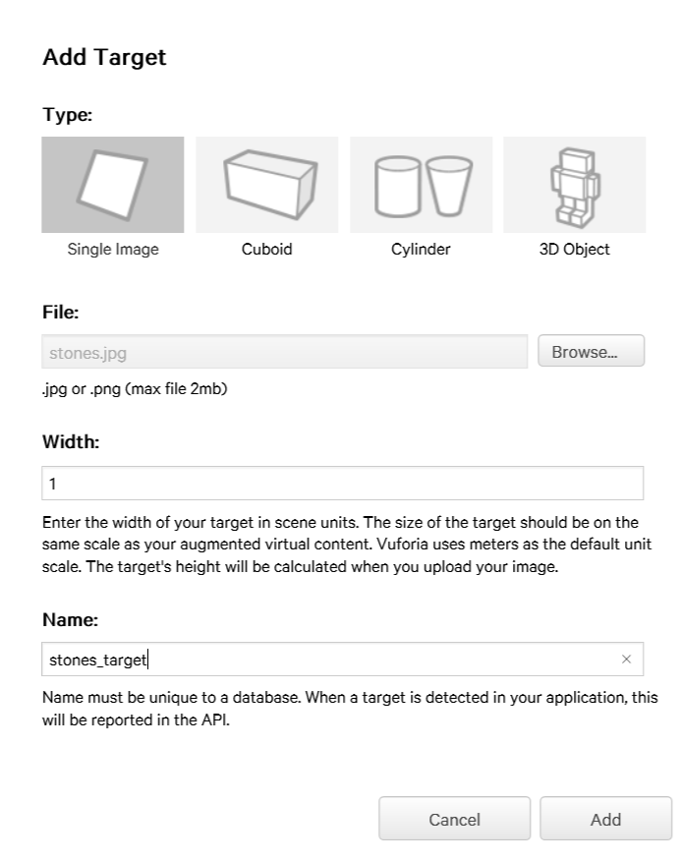

Figure 11: Window to add targets to the library.

1. We can now see that our target is already loaded in the library and is rated with 5 stars (ideal). We click Download Database (All).

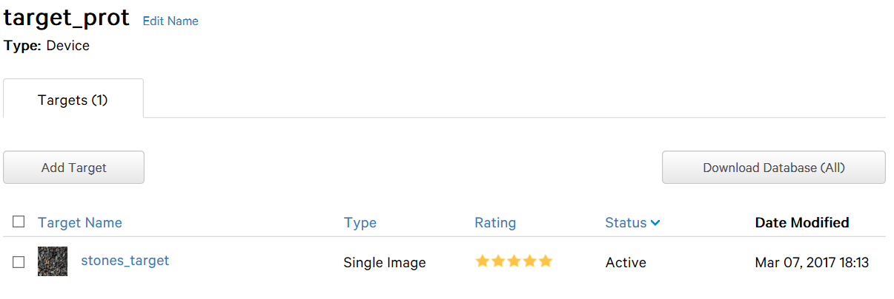

Figure 12: Updated library.

1. We specify that the development platform is Unity Editor and click Download.

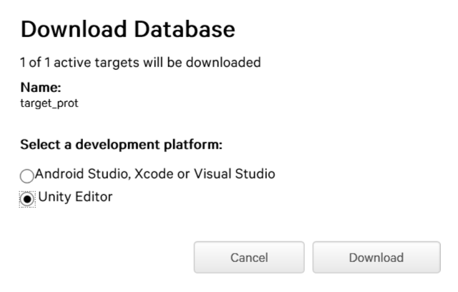

Figure 13: Window to download the library.

We will have that file nearby as we will use it shortly.

## CREATION: APPLICATION

1. We now open Unity (no account creation is necessary, it can be worked offline) and in the Projects tab, click New.

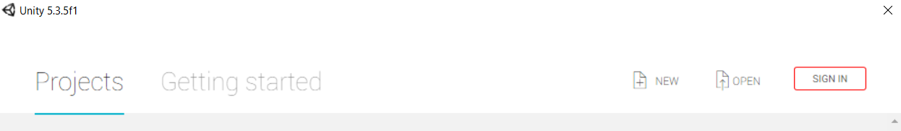

Figure 14: Unity start window.

1. We give a name and address to our project, check the 3D box if it is not checked, and click Create project.

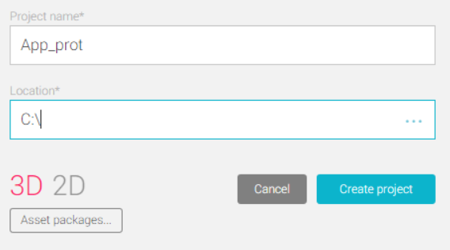

Figure 15: Project creation window.

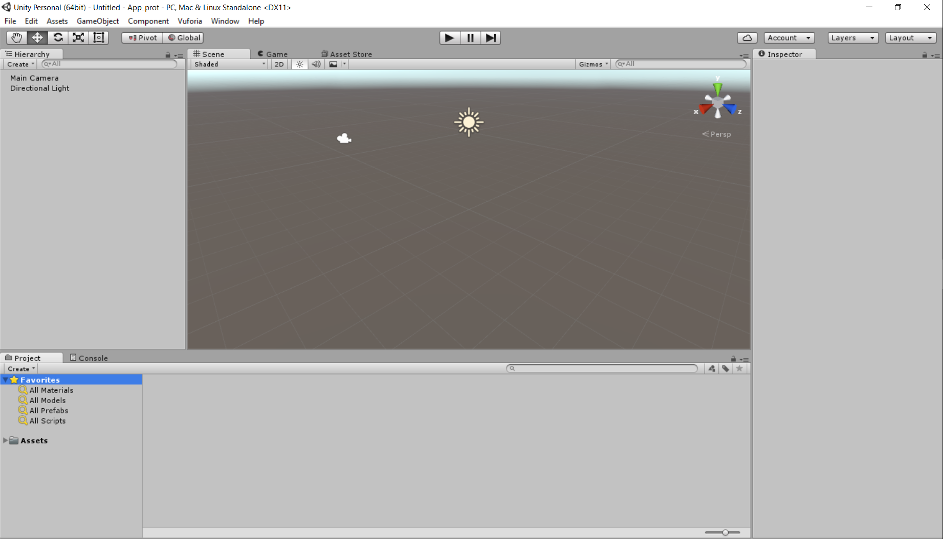

Figure 16: Newly generated project.

1. Now we double-click both the Vuforia ™ SDK and our downloaded target.

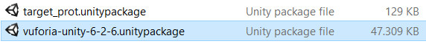

Figure 17: Files downloaded for the project.

1. We will get the following windows:



Figure 18: Package import windows.

1. Click on import and we will have the following:



Figure 19: Imported files.

1. We will start by adding the ARCamera block, which is located in Project\Assets\Vuforia\Prefabs.

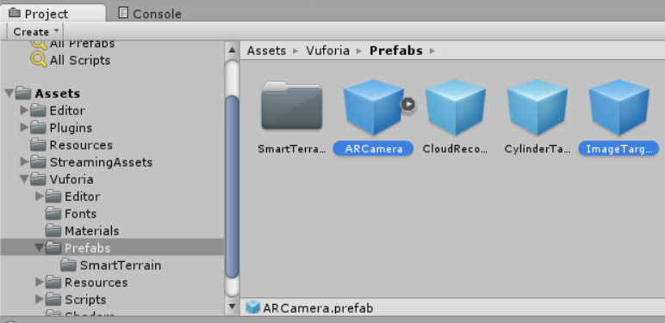

Figure 20: Folder with ARCamera and ImageTarget blocks.

1. Then, in the Inspector window (if it doesn't appear, search for its block in Hierarchy and click it once), we assign the position [0 0 0]. We repeat the process with the ImageTarget block (which is in the same folder), but we modify the rotation to [0 180 0], and we will have the following:

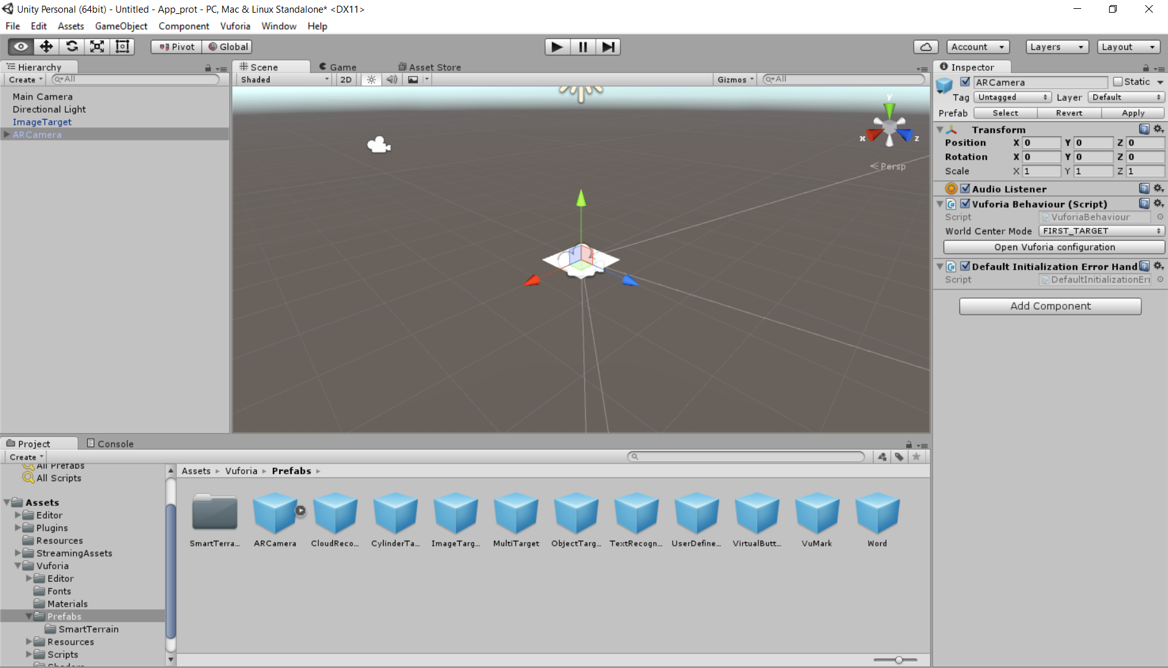

Figure 21: Camera and target blocks in the scene.

1. To activate the camera, we look in the Inspector window of ARCamera for the option Open Vuforia configuration and click on it:

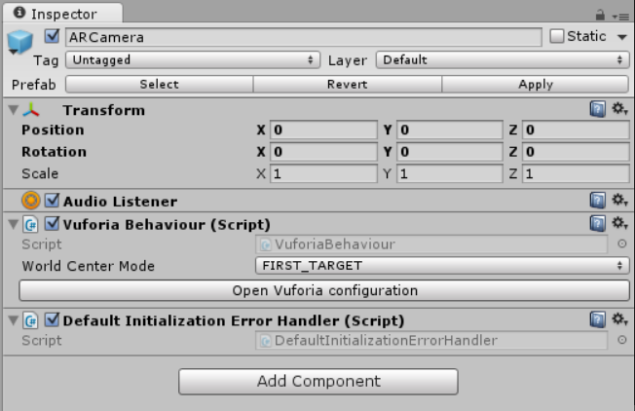

Figure 22: Inspector of the ARCamera block.

1. We copy and paste the license created in previous steps:

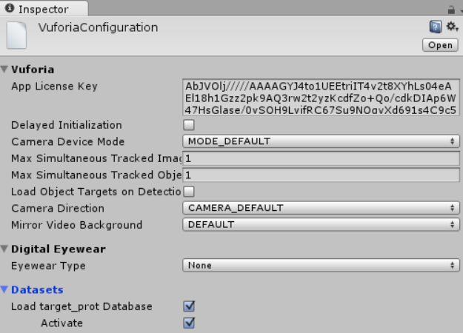

Figure 23: VuforiaConfiguration window.

We also mark the Load target_prot Database and Activate options in the Datasets tab.

1. To assign the target we created, we click on ImageTarget, check the Inspector window, and in the Database option, we select target_prot.

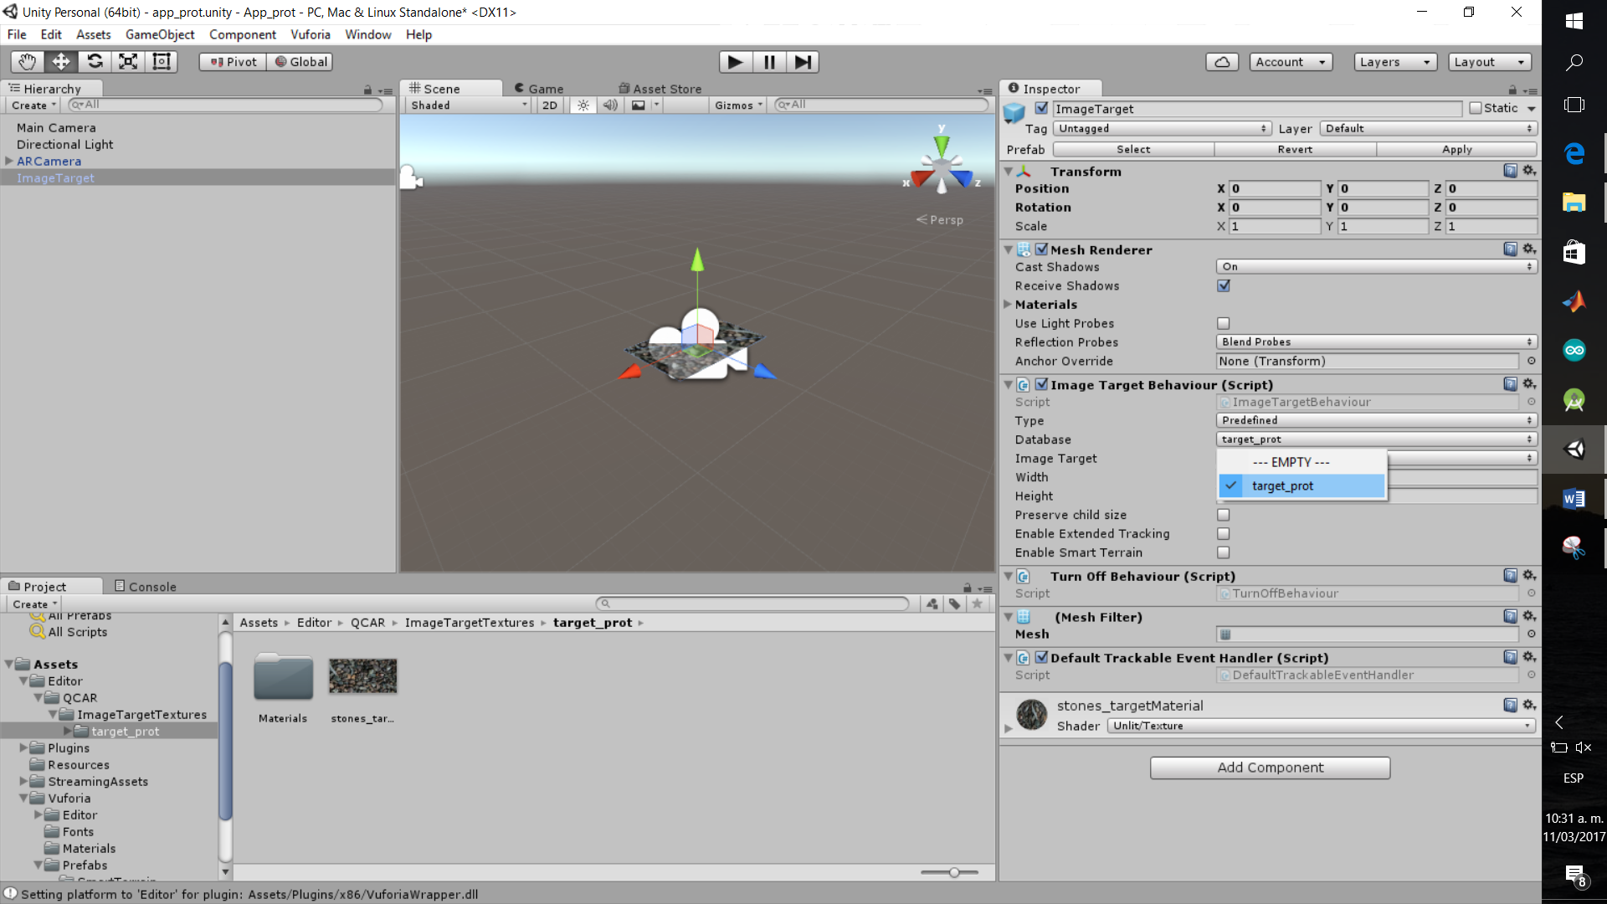

Figure 24: Inspector of the ImageTarget block.

And it would look like this:

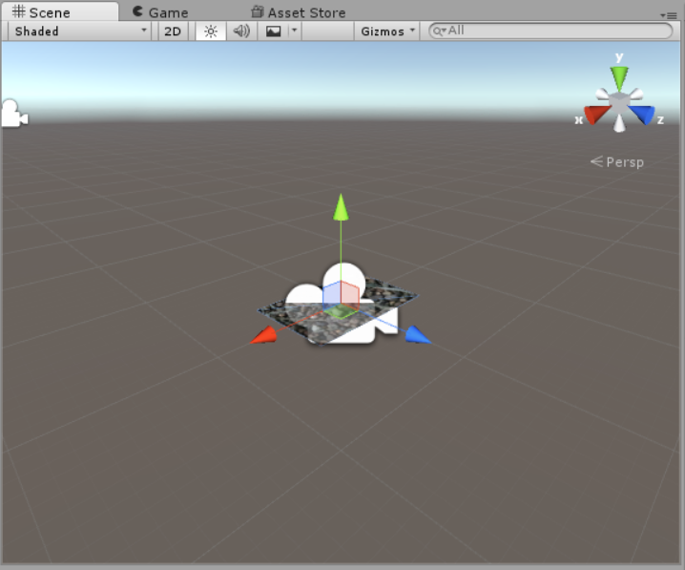

Figure 25: Scene with integrated target.

1. We will create a plane (which will float when we finish the application) and assign an image to it:

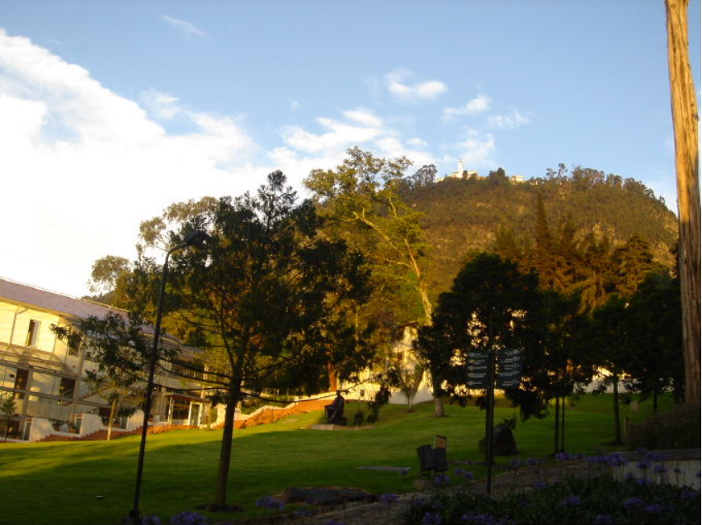

Figure 26: Photo taken by Professor Alexander Cardona from the Mathematics department (https://pentagono.uniandes.edu.co/~acardona/Uniandes1.JPG).

1. To create the plane, we go to the GameObject tab, pass through 3D Object, and select Plane. We assign the following values in Inspector:

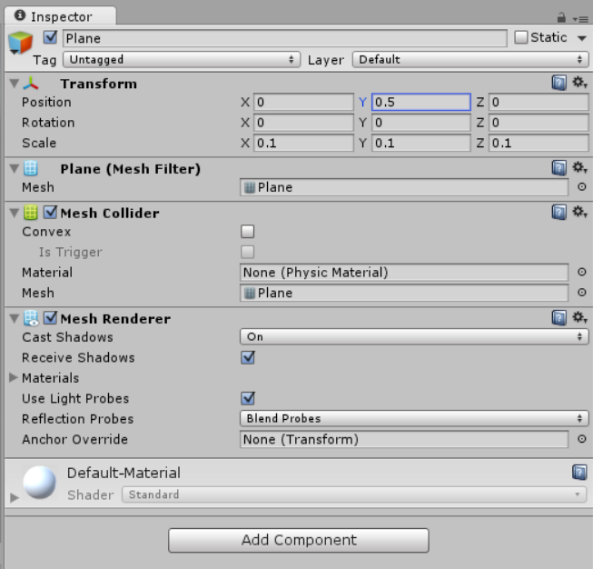

Figure 27: Inspector of the generated plane.

1. Then we drag and drop our example image into Assets and then from Assets, we move it to the plane we just created:

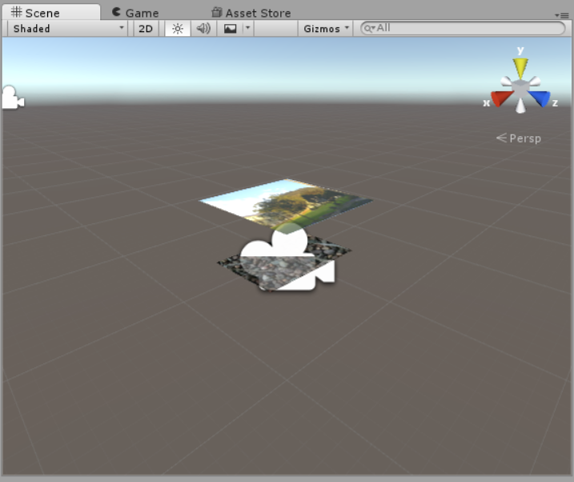

Figure 28: Scene with integrated floating plane.

1. (Optional) We create an account in Unity and go to the Asset Store window of our project:

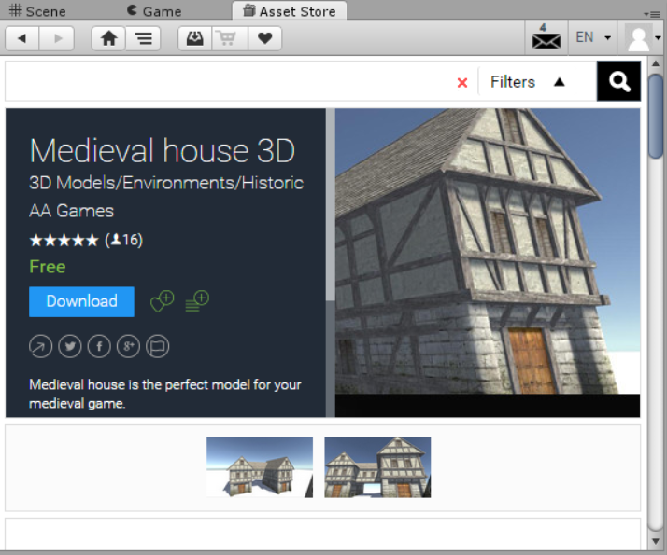

Figure 29: Unity Asset Store window.

1. You can try with this model. Click on Download and then on Import.

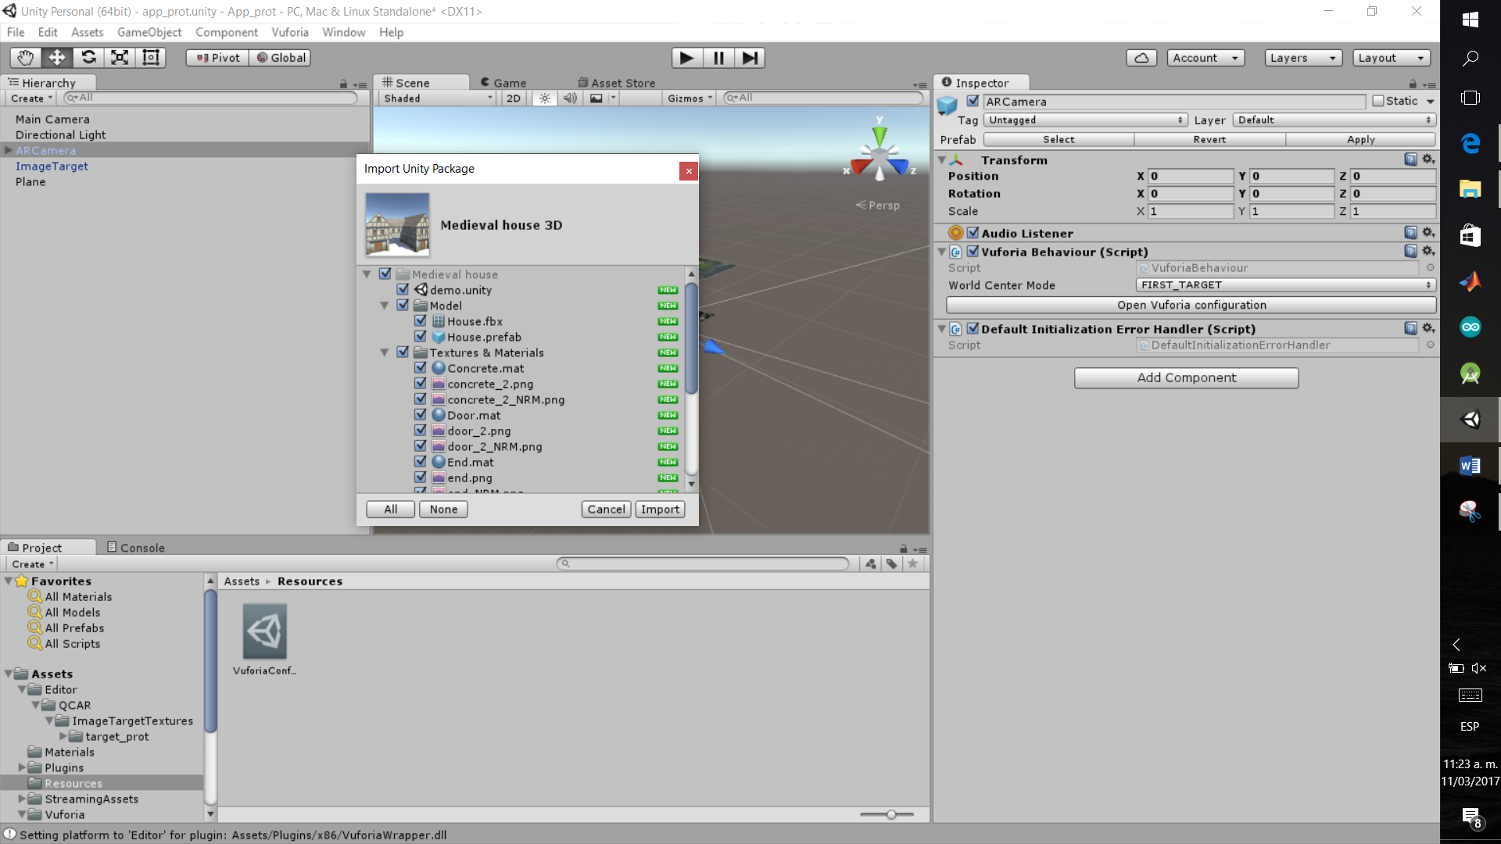

Figure 30: 3D model import window.

1. Now we will look for our medieval house model in Project\Assets\Medieval house\Model\House. We drag it, drop it onto the plane, and assign the following values:

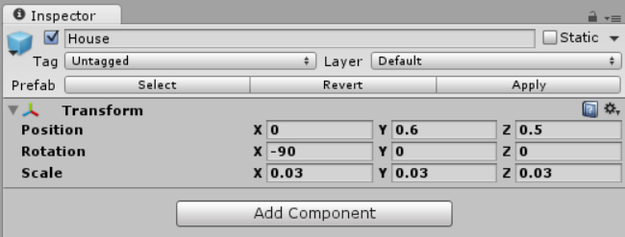

Figure 31: Inspector of the 3D model.

Then it would look like this:

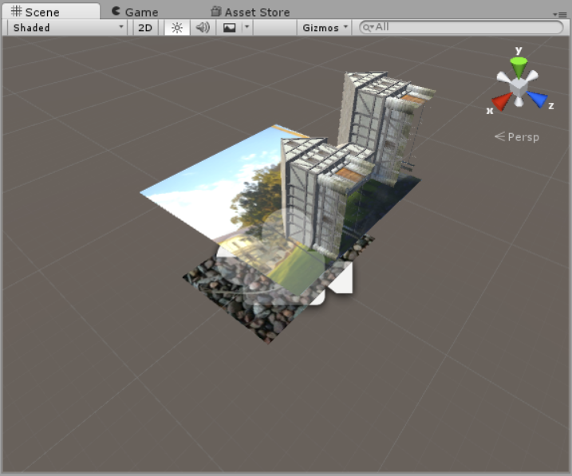

Figure 32: Scene with integrated 3D model.

1. If you want to test the App's functionality before installing it on Android, you just have to print the Target (it can be in black and white) and click on the play button of the project.

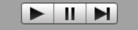

Figure 33: Program playback buttons.

## INSTALLATION: ANDROID

1. Go to the File tab of our project and click on the Build Settings... option.

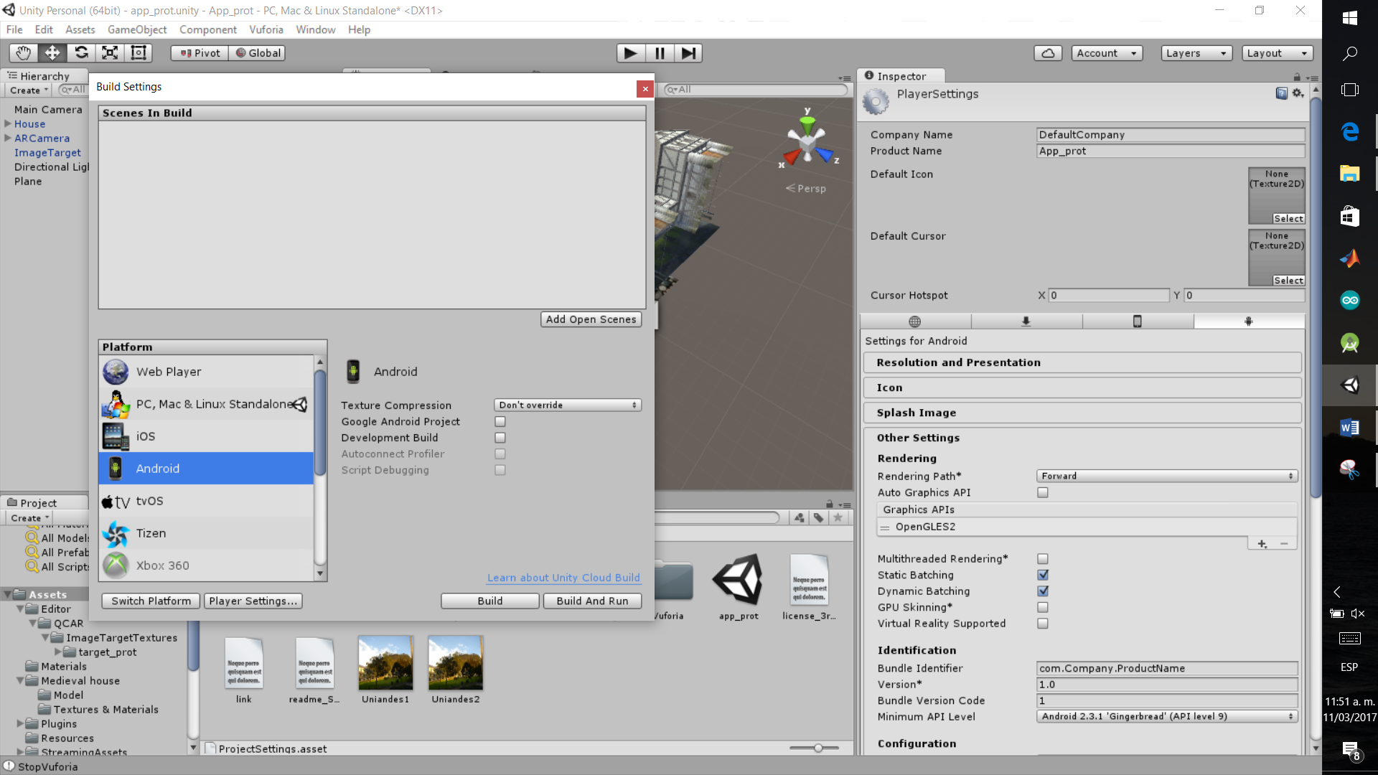

Figure 34: Application build options window.

1. Click on Player Settings:

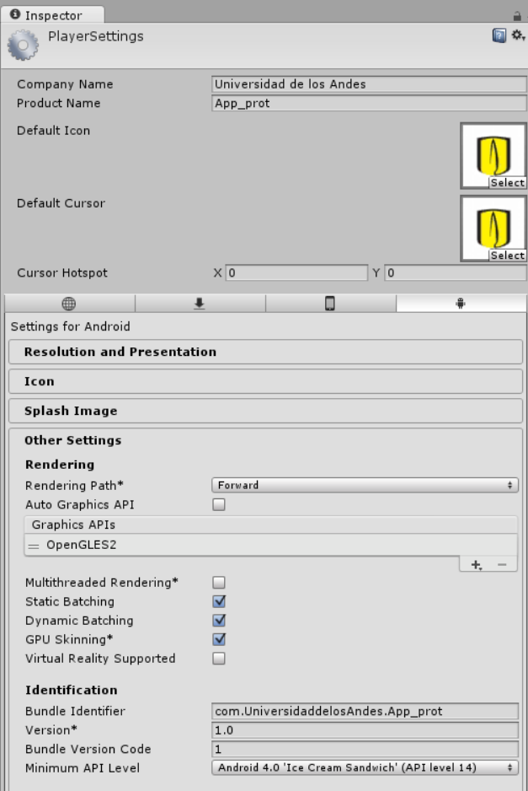

Figure 35: Application settings for Android.

1. In the inspector, we can assign an image to the application icon. In this case, we used:



Scene with integrated target (https://pbs.twimg.com/profile_images/1082842276/Uniandes-twitter_400x400.jpg).

1. To use it, we first downloaded the image, and then dragged and dropped it into the Assets folder.
2. Also, we need to consider the Minimum API Level, which is the lowest Android version that the application can support.
3. If we do not have the Android module, click on Open Download Page and follow the instructions.
4. Once everything is ready, click on Build, and it will generate the .apk file ready to be installed on any Android phone/tablet.

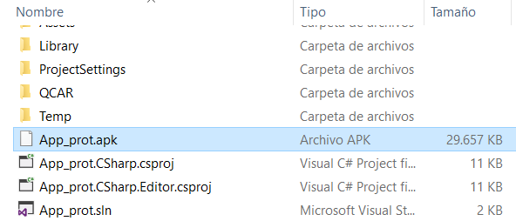

Figure 37: Generated .apk file.

1. (Optional) We can perform a direct installation by clicking on Build & Run in Build Settings... For this step, we need to enable USB debugging on our Android device.



Figure 38: Screenshots of USB debugging.

# EXPECTED RESULTS:



Figure 39: Results obtained on the Android device.

# CHANGE CONTROL

|  |  |  |  |
| --- | --- | --- | --- |
| **CHANGE DESCRIPTION** | **DATE** | **VERSION** | **APPROVED BY** |
|  |  |  |  |